Competition goals:­­­­­­­­­ ­______________________________________________________________ __________________________________________________________________________________________________________________________________________________________________________________________________________________________________________

**Checklist:**

* Sneakers for warm-up. Off-ice equipment (jump rope, spinner, stretch band, roller, yoga mat, etc.)
* Spare tights/socks
* Hockey tape, spare laces
* Warm-up jacket, gloves
* Skating dress
* Copy of music (on USB)
* Hairspray and clips, make up
* Water and healthy snacks
* Blanket and comfy clothes
* SMILE!! 😊

**What to do when arriving at competitions:**

* Arrive an hour before your event (as events can run ahead of schedule)
* Find the registration desk and check in
* Locate your dressing room and drop off bags. **NEVER** leave your skates unattended, bring them with you everywhere!
* Find your coach, if they didn’t find you when registering. Wait around the check-in table or your dressing room for them

**Off-ice warm-up/preparation:**

PLEASE NOTE: you compete how you practice; the following exercises should be done before every practice when possible so there is as little change in routine as possible

* Start with stretches to loosen up
* Cardio to warm-up and get the blood flowing
  + Jogging, skipping, hops, grape vines, jump rope, plyo-lunge-jumps, etc.
* Jump and spin warm-up
* Program walk through
* Check the ice and determine where you start your program
* Perform mental run through of your program

Get skates on ~15 minutes before scheduled to go on for warm-up

Make sure you’ve gone to the bathroom

Skate with a smile and fun!

**Stretches**

Legs:

* Leg kicks (free leg straight with pointed toes)
  + 15 low on each side
  + 15 high on each side
* Side kicks (free leg straight with pointed toe)
  + 30 each side
* Figure-8 hip rotation – 30 each side
* Toe touch (straight legs) hold 20s
* Side lunge
  + Flex toes up x10 each side
  + Sit back on heel x10 each side
* Quad stretch hold 20s each side
* Lunge with straight back leg, hips square and pushed forward 20s each side
* Hamstring stretch, left, right, both legs 20s (keep back straight)
* Split stretch, left, right, forward 20s (keep back straight)

Arms/back/shoulders:

* Arm circles, with straight arms, forward and backward x5 each way
* Shoulder stretch, keep arm straight, left, and right, 20s
* Hand on wall at 90°, walk forward and twist back, both arms 20s
* Wall downward dog, arch back, hips back 20s
* Lock hands behind back, stand with hips shoulder width apart, lean forward and let arms fall above head

**Off-ice Jumping exercises**

* Quick stretch, ankle and shoulder rolls
* ¼, ½, and full (1) rotation jumps [3x around for each]
  + Feet should be shoulder width apart, arms in ‘check’ position, and back straight
  + Bend the knees
  + When rotating keep legs uncrossed and bring in arms (slightly above the heart)
* Standing still, backspin position – free leg in ‘h’ position, arms checked [about 5x]
  + Then pull arms and leg in tight, ankle crossed (leg should have heel pressing down for tight position)
* ¼, ½, and full (1) rotation jumps with backspin position while in the air, land with both feet beside each other [3x around for each]
* Landing position – hold 3 seconds
* ½ and full rotation jumps with backspin position and landing, hold landing 3 seconds [5x]

**Jumps**

* Waltz/Axel jump
* Salchow
* Toe-loop
* Loop jump
* Flip
* Lutz

Perform as single, double, triple, quad

**Spins**

* Upright spin (layback, side, etc)
* Backspin
* Sit spin (with variations)
* Camel spin (with variations)
* Combo spin
* Flying spin

Perform using a spinner, or standing

**Relaxation techniques**

* Listen to music and go for a walk
* Stress ball or pop fidget
* Tear some paper
* Blow up a balloon
* Card games (wiz kids, solitaire, go-fish, etc.)
* Sitting or standing, tense your whole body and relax or tense from head to toe
* Counting numbers or reciting ABCs
* Take 5
  + Spread one hand out and trace up and down your fingers with the other
  + While tracing up breathe in through your nose, while tracing down breathe out through your mouth
* 5, 4, 3, 2, 1 exercise
  + 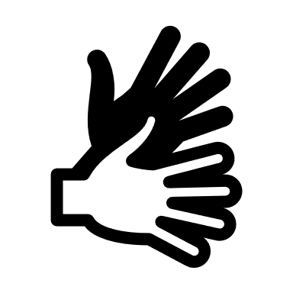5 things you can see
  + 4 things you can feel
  + 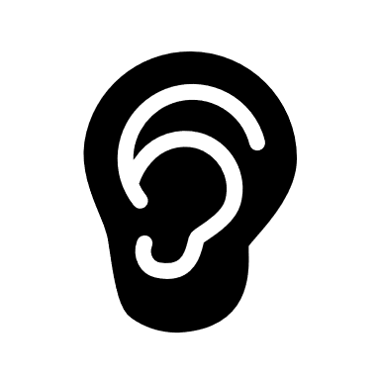3 things you can hear
  + 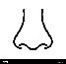2 things you can smell
  + 1 thing you can taste
* 4-7-8 breathing
  + In through nose (4s)
  + Hold (7s)
  + Out through mouth (8s)
* Positive self-talk